How to enroll in classes with
- Go to www.flvs.net then click enroll.
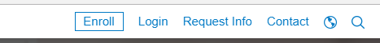

2. Select County Virtual School.
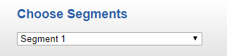
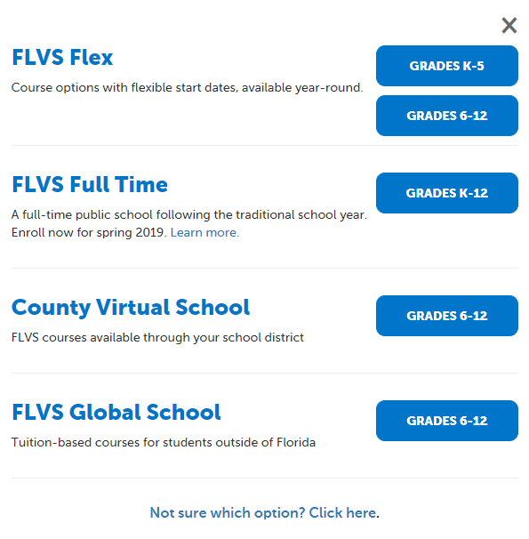
5. Select your course then the semester that you want to take

6. Choose your start date
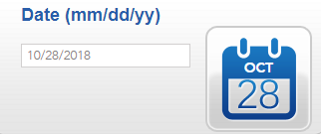

3. Click this button to start creating your account

4. Pick Osceola County and Public/Charter School 7. Pick Osceola Virtual Secondary.
Student from the drop-down menu. Please contact (407) 870-1445 if not listed
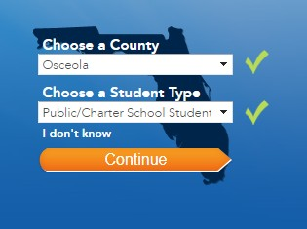
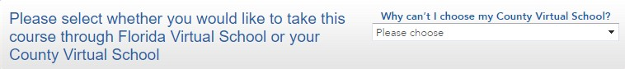

8. Click on Create My Account

Course: ______________________ Segment: _____ Start Date: ______________

2020-21 High School Course Offerings
Language Arts
English 1 (H)
English 2 (H)
English 3 (H)
English 4 (H)

Mathematics
Algebra 1 (H)
Algebra 2 (H)
Geometry (H)
Liberal Arts Mathematics 1
Math for College Readiness
Pre-Calculus (H)

Science
Anatomy and Physiology (H)
Biology 1 (H)
Chemistry (H)
Earth-Space Science (H)
Forensic Science
Marine Science 1 (H)

Social Studies
Economics (H) (S)
United States Government (H) (S)
United States History (H)
World History (H)

Health/Physical Education
Fitness Lifestyle Design (S)
Health Opportunities through Physical Education (HOPE)
Personal Fitness (S)

(H) Honors Available (S) Semester Course

World Languages
Spanish 1
Spanish 2
Spanish 3 (H)

Electives
Career Research & Decision Making (S)
Driver Education/Traffic Safety (S)
Parenting Skills (S)
Psychology 1 (S)
Peer Counseling 1 (S)
Peer Counseling 2 (S)
Peer Counseling 2 ELL (S)

Advanced Placement
(List upon request)

Middle School Course Offerings
Language Arts
M/J Language Arts 1
M/J Language Arts 2
M/J Language Arts 3

Mathematics
M/J Mathematics - Grade 6
M/J Mathematics - Grade 7
M/J Pre-Algebra - Grade 8

Science
M/J Comprehensive Science 1
M/J Comprehensive Science 2
M/J Comprehensive Science 3

Social Studies
M/J World History - Grade 6
M/J US History – Grade 7
M/J Civics – Grade 8

Please check OVS website for more information: ovss.osceolaschools.net

